THEORY QUESTIONS
1.
(a)

In an experiment, an iron bar is magnetized by dragging a magnet over the surface of the bar from end A to end B several times as shown in the diagram below.
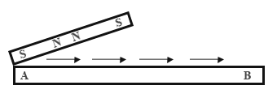
(i)

Mention the method of magnetization.
(ii)

Give the polarity of the ends A and B of the bar after the magnetization.
(iii)

How will you test that the bar AB is a magnet?
(iv)

Indicate how you will test for the poles of A and B of the bar.
(v)

Give one precaution that should be taken during the magnetization process.
(vi)

Name one other method of magnetization.
(b)

The set-up below is used to prepare gases in the laboratory.
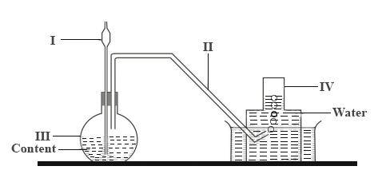
(i)

Give the names of the parts labelled I, II, III and IV.
(ii)

Write down the two names of the method of gas collection.
(iii)

Explain how the gas collects over the water.
(iv)

Name two gases that can be prepared using the set-up.
(c)

The set-up below shows air being breathed out through the mouth into test-tube containing lime water.
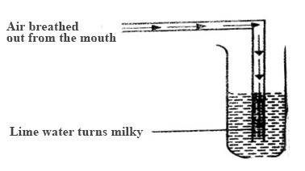
(i)

Why does the lime water turn milky?
(ii)

Identify the milky substance produced.
(iii)

Write a balanced chemical equation for the reaction.
(iv)

Name two other substances present in breathed-out air.
(v)

What is the aim of the experiment?

2.
(a)

What is a living cell?
(b)

Give one function of each of the following components of a living cell:
(i)

cell membrane
(ii)

chloroplast
(iii)

nucleus
(c)

Make sketches to show the arrangement of the particles in each of the three states of matter.
(d)

What instrument would you use to measure each of the following quantities:
(i)

volume of a liquid
(ii)

mass of a stone
(iii)

time
(iv)

speed of the wind?

3.
(a)

Name three deficiency diseases associated with diet and state their causes.
(b)

(i)

What is hard water?
(ii)

Mention three ways by which hard water can be made soft.
(c)

(i)

Explain how sound is produced.
(ii)

State one example each of the following instruments:
(α)

wind instrument
(β)

string instrument

4.
(a)

State two examples of a
(i)

carnivore;
(ii)

herbivore.
(b)

What is the difference between egestion and excretion?
(c)

Explain briefly why
(i)

gold is used to make necklaces and earrings.
(ii)

steel is used instead of iron to make car bodies
(d)

(i)

What is surface tension?
(ii)

Explain why the surface of water in a container is not flat but curved.

5.
(a)

Copy and complete the table below:
Disease | Causative Agent | Prevention/Control
Cholera | Vibrio spp. | Eating hot food
i) ..................... | Plasmodium | ii) ......................
iii) .................... | Louse | Personal hygiene
Ringworm | iv) ........................ | v) ..................................
(b)

Name two different particles of matter which carry
(i)

a negative charge;
(ii)

a positive charge;
(iii)

no charge.
(c)

A simple machine moves a load of 20 N through a distance of 2 m. If it uses an effort of 25 N which moves through a distance of 4 m, calculate the
(i)

work input;
(ii)

work output;
(iii)

efficiency of the machine.

